* Condition If statement.
* Check the variable

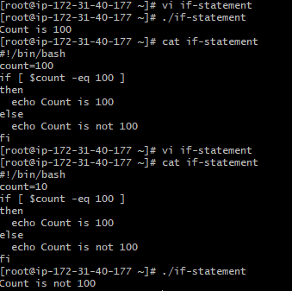

* Check if a file shahnawaz exist.

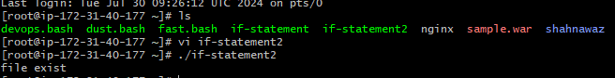

* Check if a variable value is met

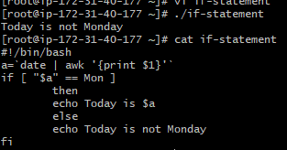

* Check the response and then output.

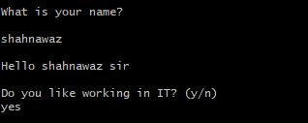

Case Statement Script.

* case Scripts

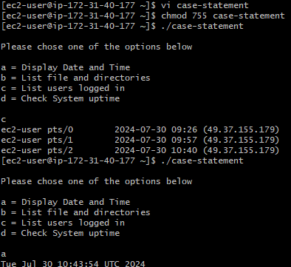

* This script will look at your current day and tell you the state of the  
  backup.

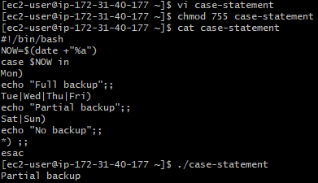

For loop Scripts:

* Simple for loop output

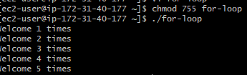

* Simple for loop output

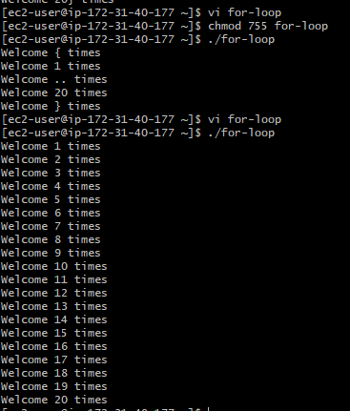

* Simple for loop output.

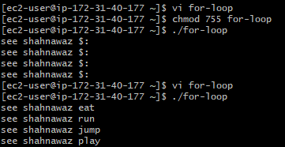

* For loop to delete 5 files

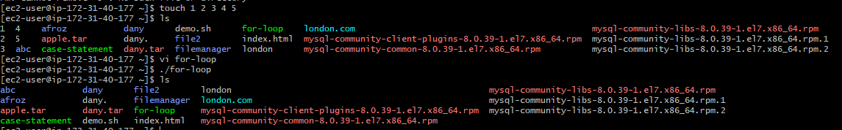

* Specify day in for loop.

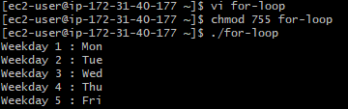

* List all users one by one from /etc/passwd file.

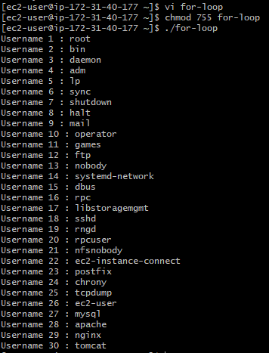

Do-while Script.

* Script to run for a number of times

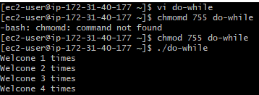

* Script to run for a number of seconds.

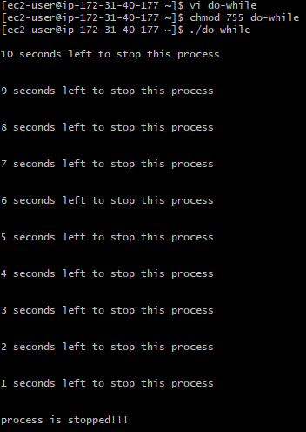\

Exist Stauts.

* Return Successful Exist Status.

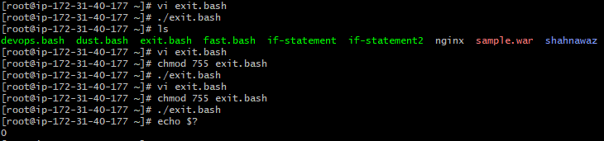

Cornjobs.

* 